**Blumentöpfe aus PET-Flaschen selber machen**

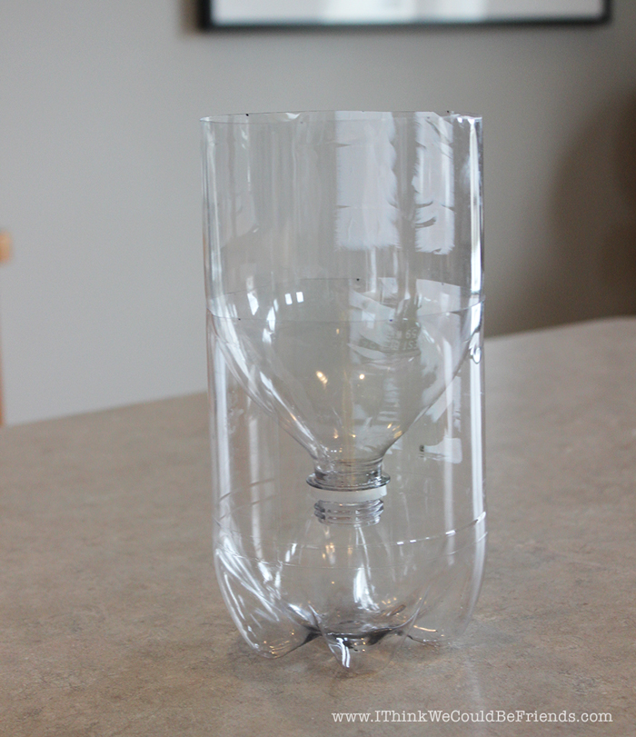

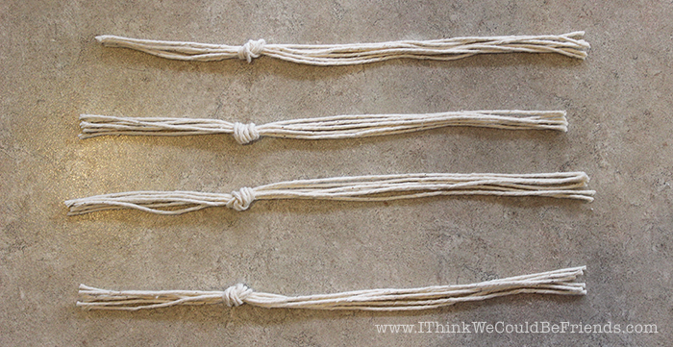

**[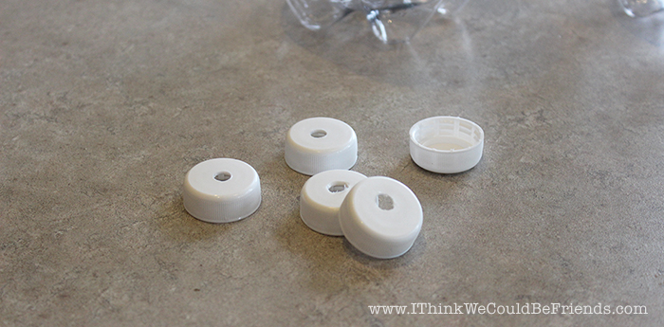](https://www.ithinkwecouldbefriends.com/wp-content/uploads/2015/04/Herbs-Seeds.jpg)**

**[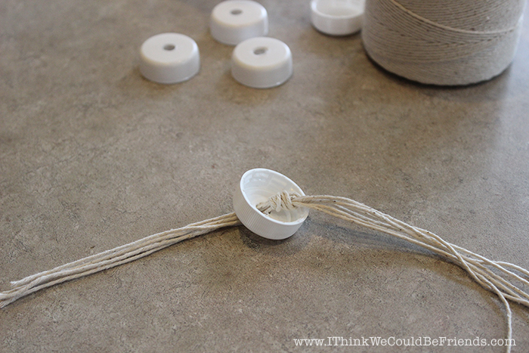](https://www.ithinkwecouldbefriends.com/wp-content/uploads/2015/04/Herbs-Seeds.jpg)**

**[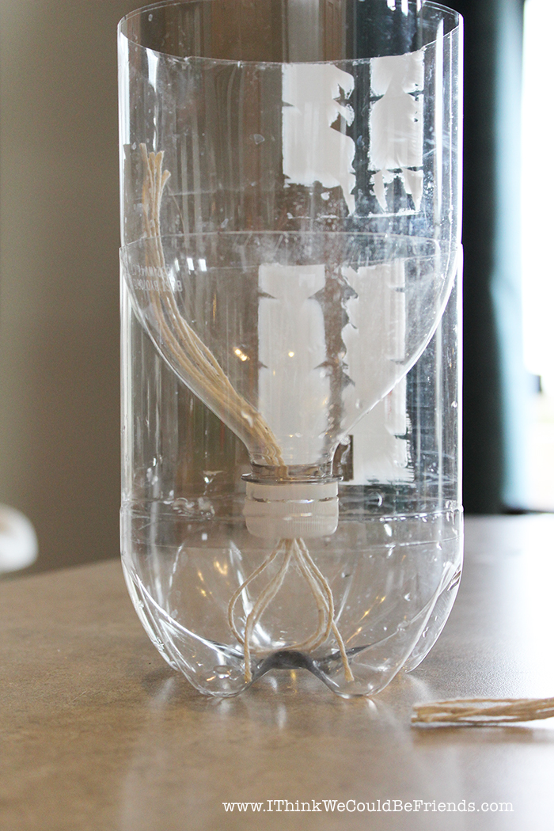](https://www.ithinkwecouldbefriends.com/wp-content/uploads/2015/04/Herbs-Seeds.jpg)**

**[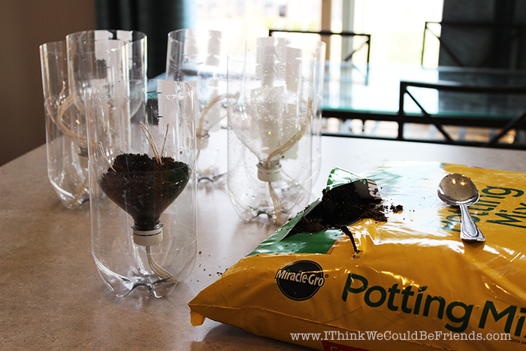](https://www.ithinkwecouldbefriends.com/wp-content/uploads/2015/04/Herbs-Dirt-Partial.jpg)**

**[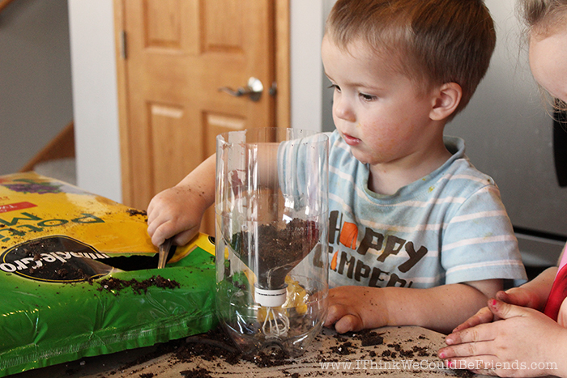](https://www.ithinkwecouldbefriends.com/wp-content/uploads/2015/04/Herbs-Seeds.jpg)**

**[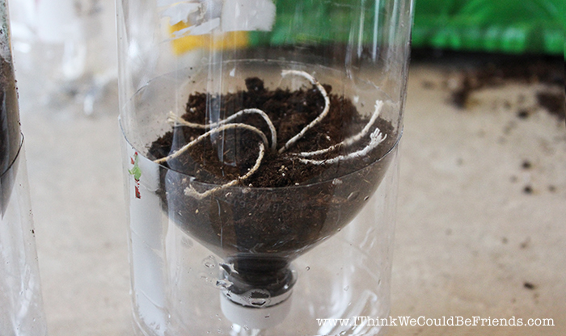](https://www.ithinkwecouldbefriends.com/wp-content/uploads/2015/04/Herbs-Seeds.jpg)**

**[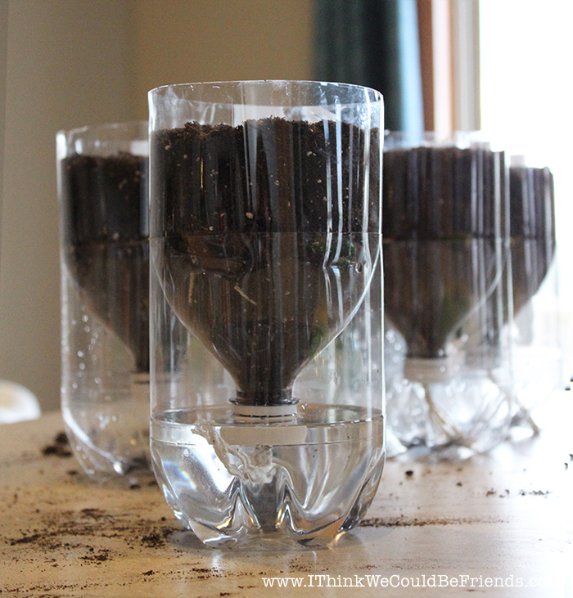](https://www.ithinkwecouldbefriends.com/wp-content/uploads/2015/04/Herbs-Seeds.jpg)**